

| Business Template  **Project Design Essentials** |
| --- |
|  |

## PART A

First, I created **two slicers** for the **Customer Full Name** field — one configured as a **dropdown list** and the other as a **vertical list**. This allows users to filter customers in two different formats, enhancing usability based on preference.

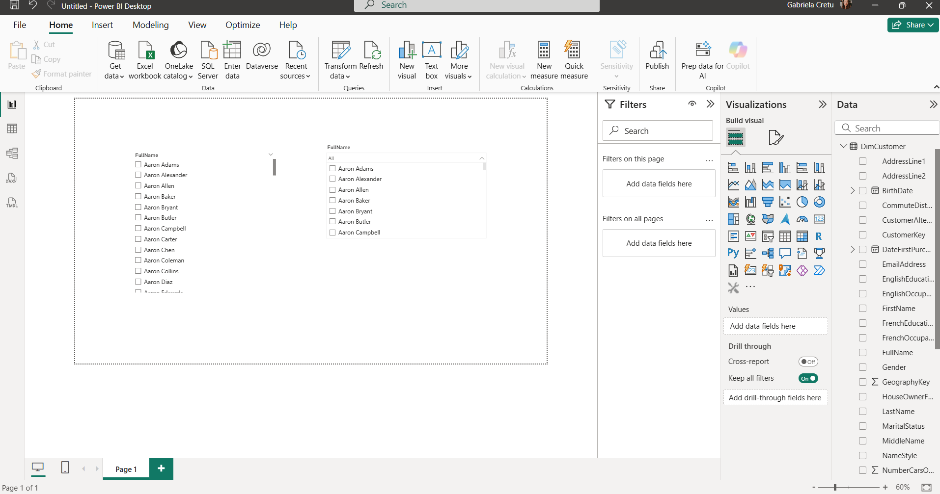

Next, I enabled the **search option** for each slicer by clicking the **three-dot menu** (•••) in the top-right corner of the slicer and selecting **"Search"**. This makes it easier for users to quickly find specific entries, especially in long lists.

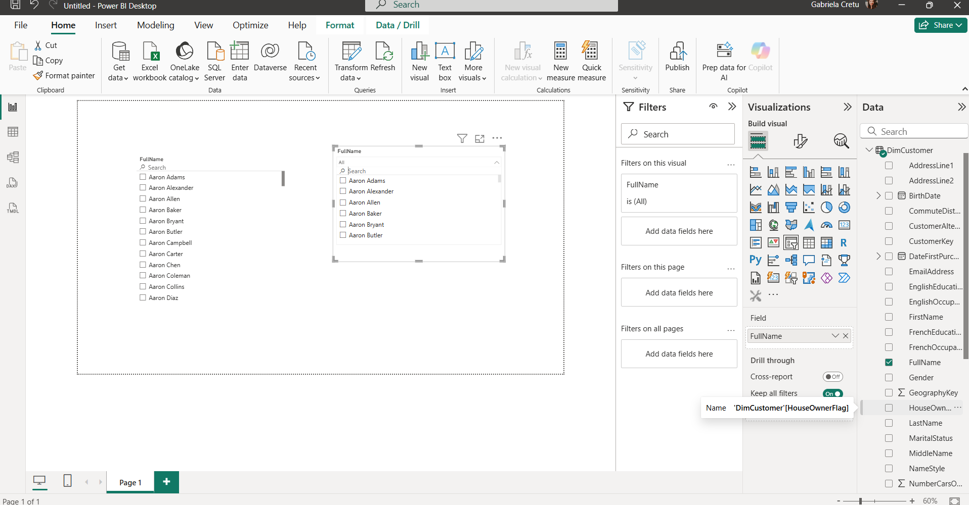

Next, I imported a **custom visual** from the **AppSource marketplace** by clicking the three dots in the Visualizations pane and selecting **“Get more visuals”**. From there, I browsed and added a visual that suited the report’s needs.

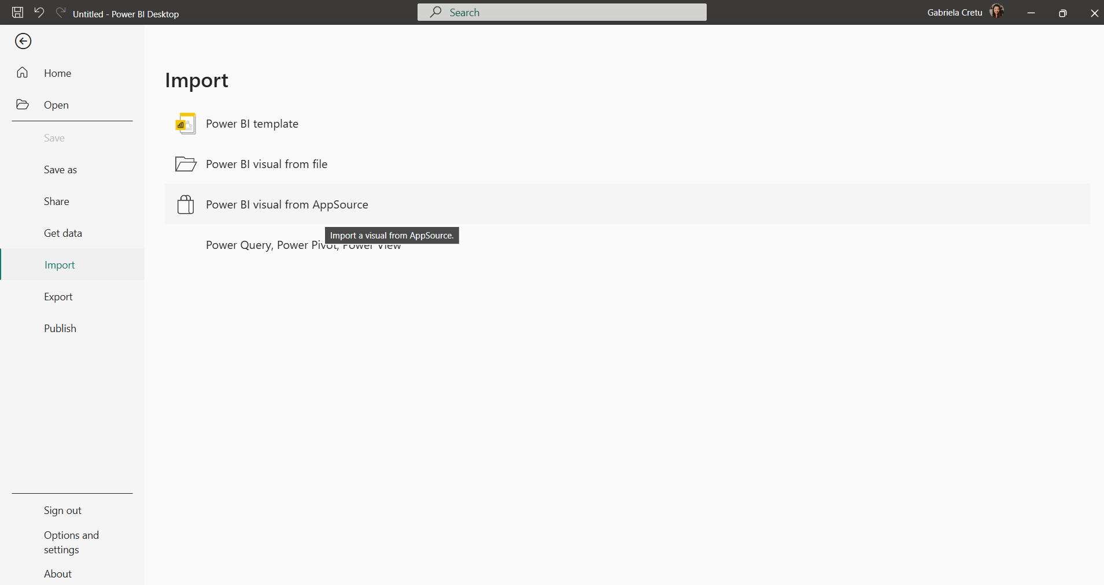

## PART B

I began by creating the report layout and adding a **company logo** along with a **report title**: *Sales Performance Dashboard*. The company name used was **FACT360ANALYTICS**, which reflects our role in collecting and analyzing global internet sales data.

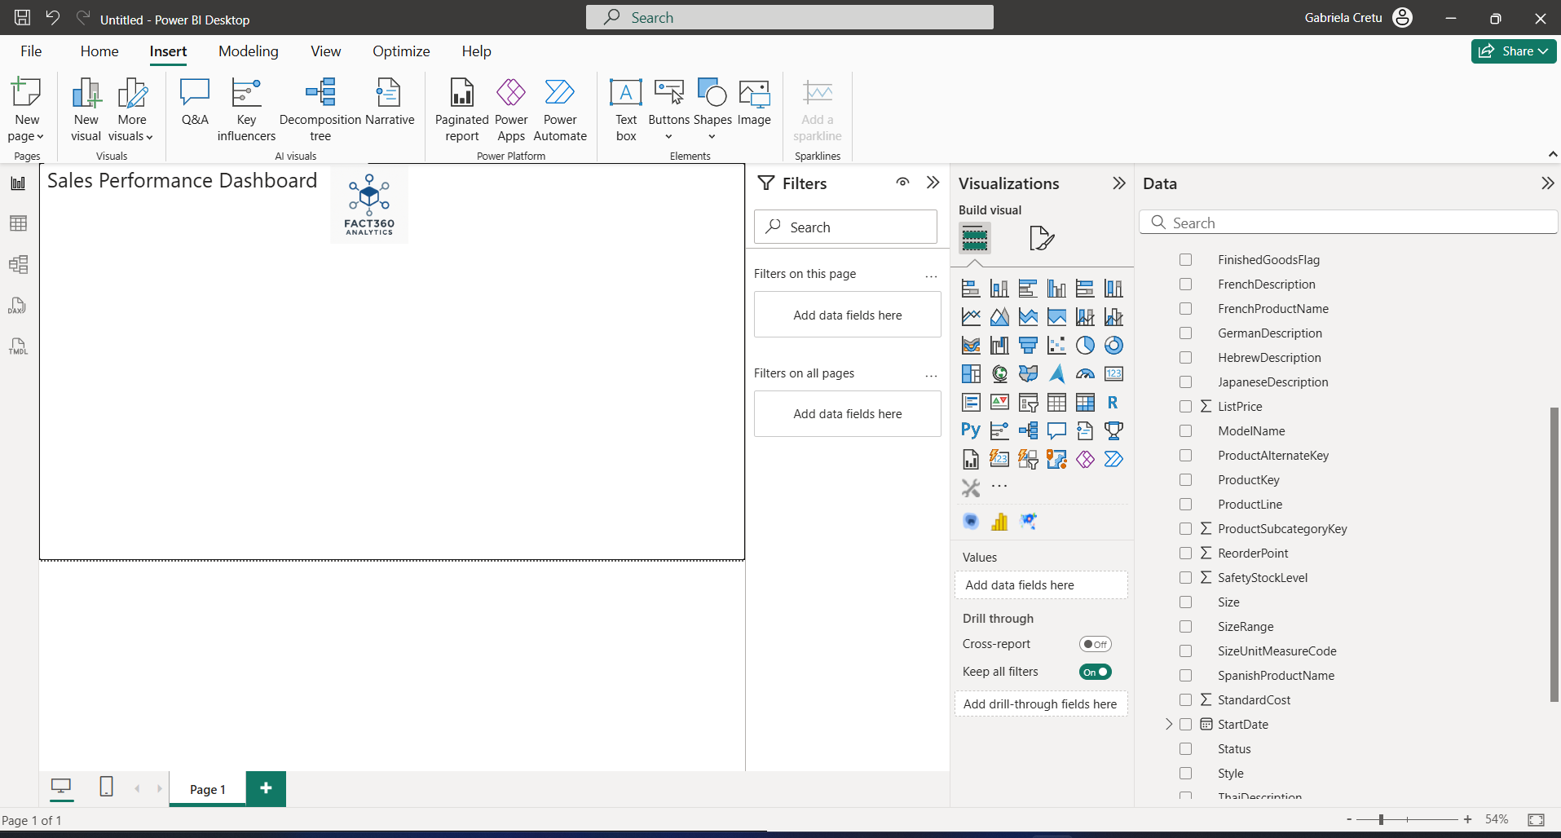

Next, I set up three slicers to make the report both user-friendly and space-efficient. For **products** (*DimProduct*), I used a **dropdown**  for the model names with a built-in search box, keeping the layout compact while still allowing quick lookups. For **customers** (*DimCustomers*), I chose a **list** with search enabled for the full name column, so users can either scan through visible names or jump straight to a specific one. Finally, for the **date alternate key** (*DimDate*), I applied the **Between** option, giving a clear and intuitive way to filter by a continuous date range. Together, these choices strike the right balance between clarity, speed of selection, and efficient use of screen real estate.

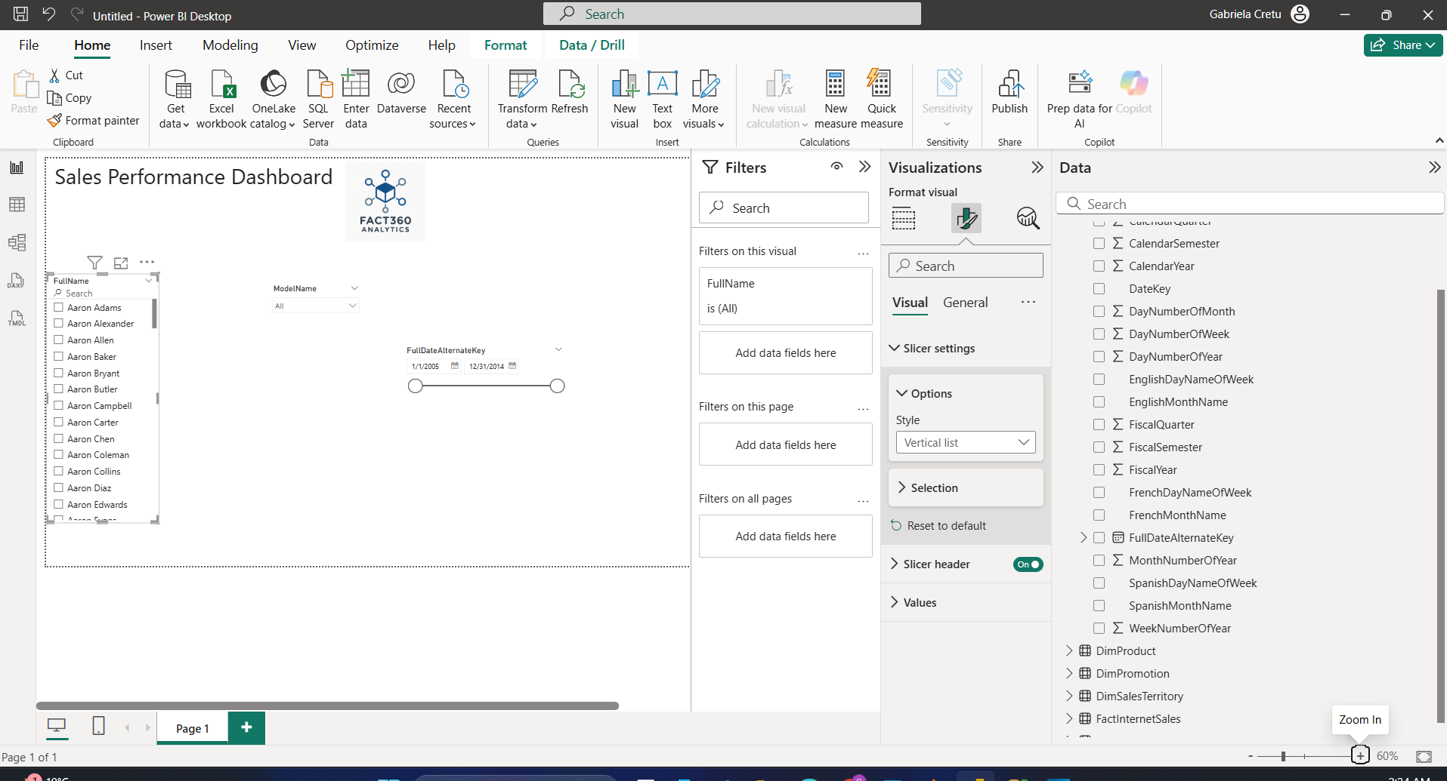

To create the first five visuals, I focused on logical business metrics typically used to evaluate company performance.

I began with a **KPI visual**, where the **target value** was set to *Total Product Cost* and the **tracked value** was *Sales Amount*, with the **trend based on time**. This setup helps assess whether the company is generating positive net revenue. The visual showed that overall revenue was positive, with a noticeable spike in recent periods.

Next, I used a **Pie Chart** to analyze which **sales territory group** contributed most to the *Sales Amount*. The distribution appeared fairly balanced, with **North America slightly leading**, which aligns with its role as a major global economic player.

To further explore contributions by product, I introduced a **Ribbon Chart** comparing **Model Names** by their sales over time. Initially, the **Road-150** model had the highest share of total sales, but over time, the **Mountain-200** model—introduced later—quickly took over, demonstrating a shift in product popularity.

For deeper insight into profitability by region, I created a **Scatter Chart** comparing **Total Product Cost** against **Sales Amount** by country. The data points followed an almost linear pattern, indicating that no country significantly outperformed others. This suggests consistent cost-to-sales relationships across markets, with no standout case of extremely low cost and high sales.

Finally, I added a **Line Chart** to track **Sales Amount over time**. The chart revealed a sharp increase in sales in **2013**, followed by a noticeable drop, highlighting a peak in performance during that specific period.

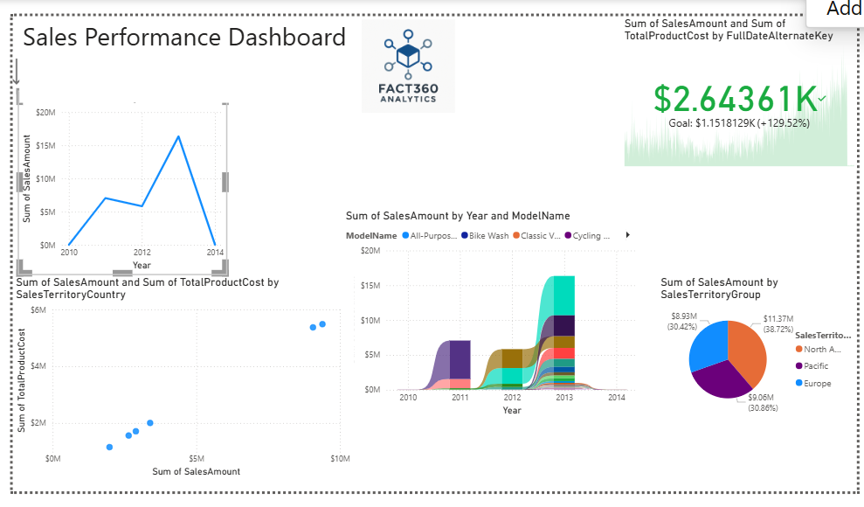

Next, I added two custom visuals. The first was a **Histogram Chart** that displayed the distribution of sales amounts per transaction using a set number of bins. It showed that the most common transaction amount was **$4.99**, with approximately **8,827 transactions** falling into this category. To achieve this, I applied an **Index** to uniquely identify each transaction. This was necessary because the histogram aggregates values into ranges and calculates the frequency of those sums; without a unique identifier, we couldn't accurately measure the sales amount per individual transaction.

The second visual was a **Power KPI 2.0**, which plotted the **sum of unit cost** and **sum of unit price** across a specified date range. This visual suggested that the company remained profitable over time, though there was a **variance of approximately 60–70%** in the relationship between cost and price.

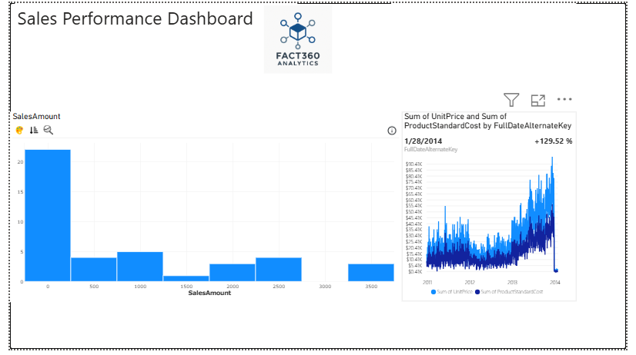

To eliminate the interaction between the **Pie Chart** (which displays *Sales Amount per Territory Group*) and the slicers previously added, I used the **Edit Interactions** feature. I selected the pie chart, then navigated to the **Format tab** and clicked on **Edit Interactions**. On the other visuals (such as the slicers), a set of interaction icons appeared. I clicked the **slashed circle icon** on each slicer related to the pie chart, effectively disabling their filtering influence. This ensured that the pie chart remains unaffected by selections made in the slicers, allowing it to display an unfiltered overview of sales distribution by territory.

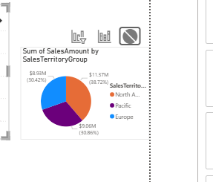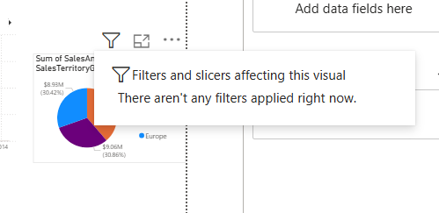

I chose a color palette primarily consisting of light blue and marine blue tones. However, in some visuals, there weren’t enough variations of blue to distinctly represent all the elements, leading to occasional deviations in color usage.

Next, I added a bubble map in Power BI that visualizes cities within each country region based on occupation. The size of each bubble represents the count of customers in specific occupations within those cities and regions.

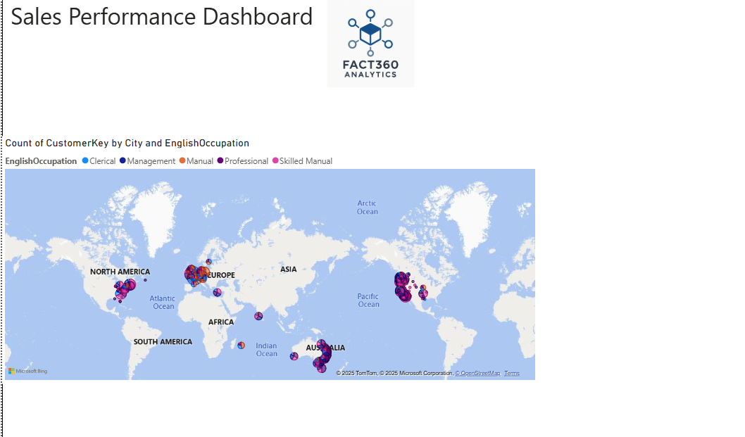

After creating the bubble map in Power BI, I set up the mobile layout for my report.

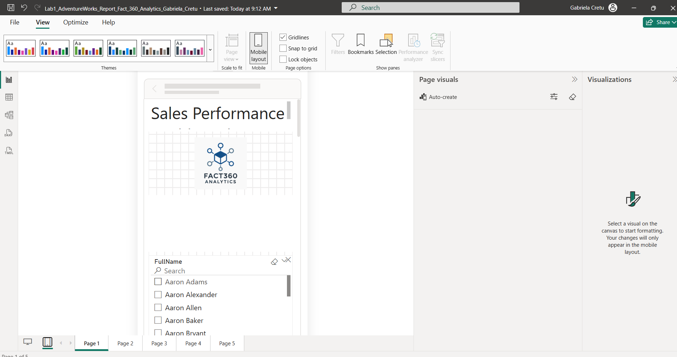

Next, I published my report to MyWorkspace.

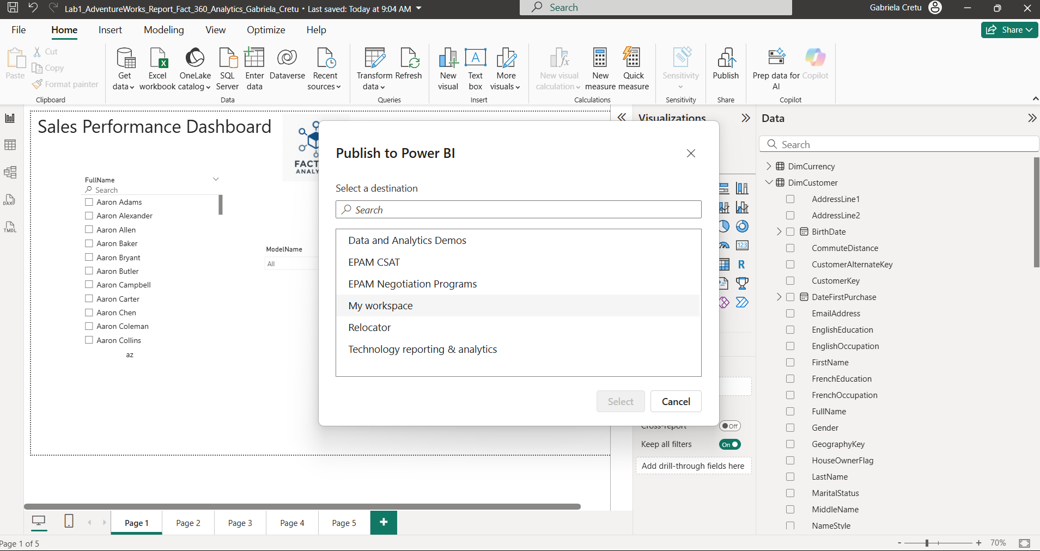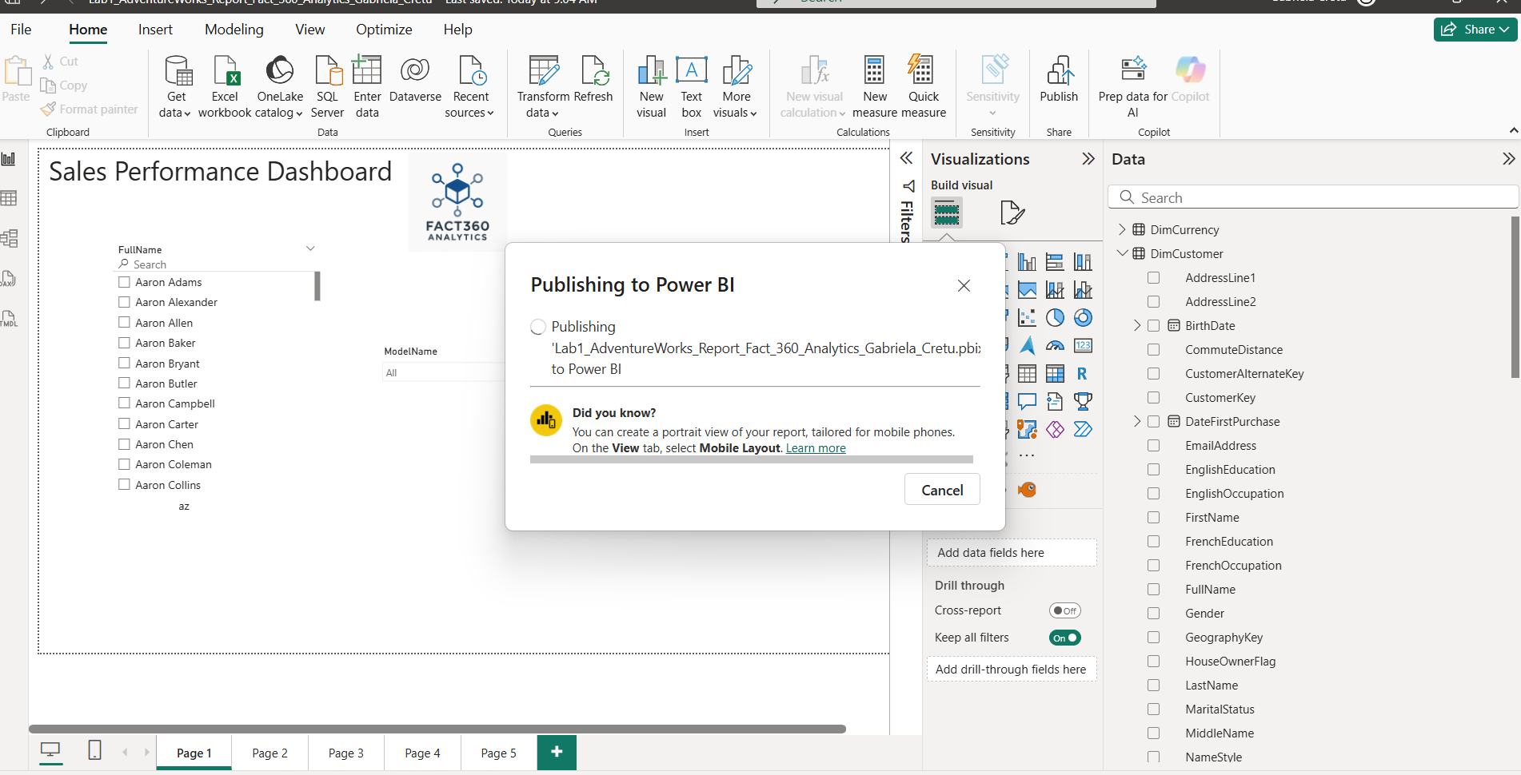

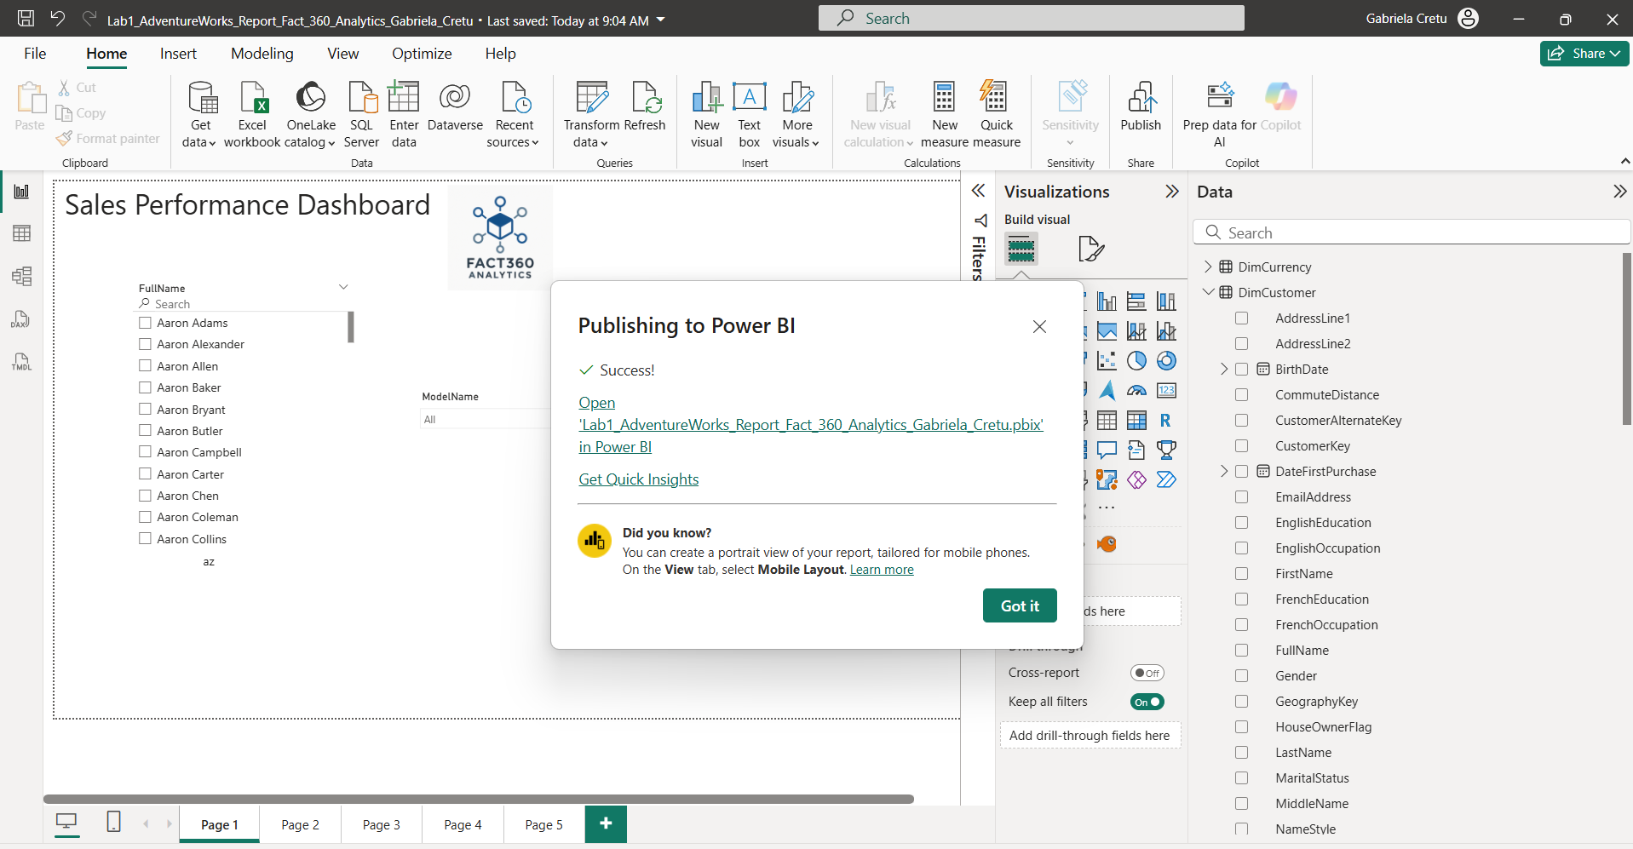

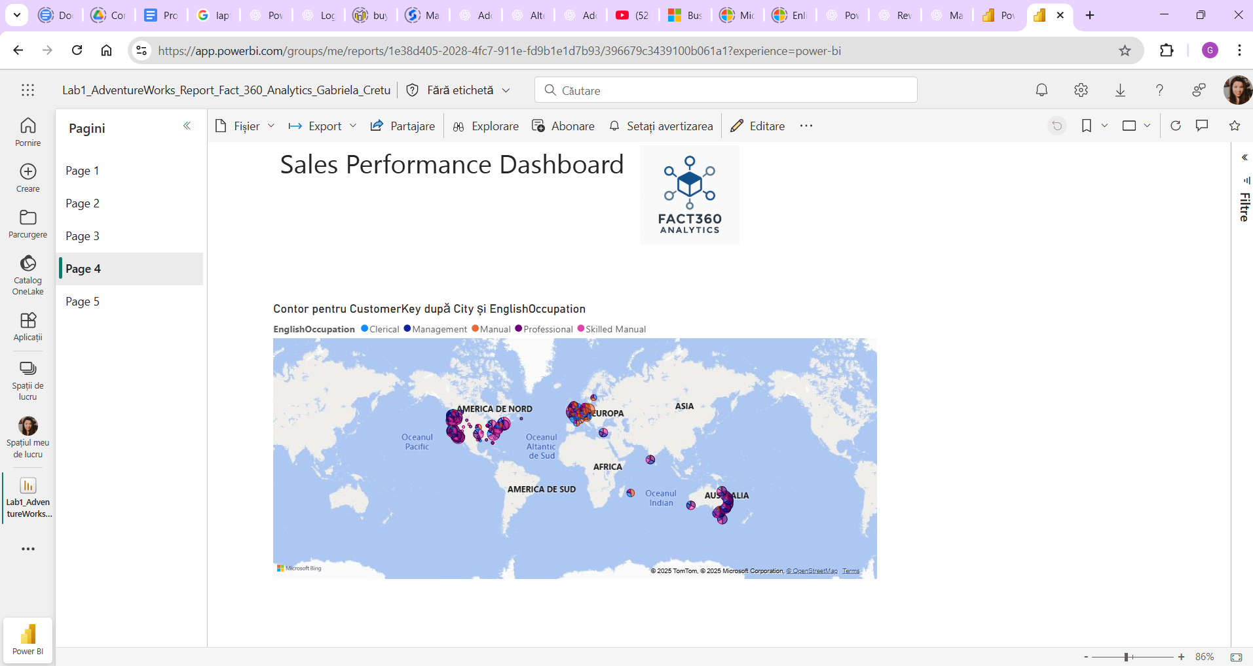

Next, I installed the on-premises data getaway.

